RF Project
Definitions:
Hounsfield units (HU)- are a standardized scale used in CT scans to quantify tissue radiodensity, with water defined as 0 HU and air as -1000 HU.

The Storage Format: Sparse Voxel Indexing
All CSVs use a flat voxel index as the row key rather than storing a full 3D grid. The native patient volume is 128×128×128 = 2,097,152 voxels, but only non-empty voxels are saved. This is why:
- ct.csv has ~81K rows — the rest of the grid is air/background (HU ≈ 0)
- dose.csv has ~65.5K rows — only voxels inside the treatable region
- Structure CSVs have no data column at all — the index is the mask (presence = 1)
The flat index encodes 3D position as: index = z × 128 × 128 + y × 128 + x
Example — first row of ct.csv
Flat Index | z | y | x | HU
532,261 | 32 | 62 | 37 | 18.0
To go backwards (index → coordinates):
z = index // 16384 (16384 = 128×128)
y = (index % 16384) // 128
x = index % 128

The Files in Detail
voxel_dimensions.csv — the spatial resolution: 3.906 × 3.906 × 2.5 mm per voxel. Note this is anisotropic (z is finer). This matters when resampling to the 64³ target — you'll need to account for the different z spacing, not just divide by 2.
ct.csv — CT scan in Hounsfield Units (says "what material is at this location"). 81,257 non-zero voxels, ranging from 1–3976 HU. The upper end (>3000) is likely metal artifact or bone with contrast, and the preprocessing pipeline clips at 3000 before normalizing to [−1, 1], which is correct.
dose.csv — the ground-truth clinical dose distribution, 65,541 voxels, ranging 1.12–74.23 Gy, mean ~44 Gy. This is only used for the terminal DVH bonus and final evaluation — never as a state input.
possible_dose_mask.csv — exactly the same 65,541 voxels as dose.csv. This defines where the beam can physically deposit dose. The DIM matrix should only be non-zero within this region.
File | Contains
ct.csv | HU value (tissue density) for each non-empty voxel in the CT scan
dose.csv | Total radiation dose in Gy received by each voxel after all 35 treatment fractions
possible_dose_mask.csv | List of voxels where beams can physically deposit dose
voxel_dimensions.csv | Physical size of one voxel in mm (3.906 × 3.906 × 2.5)
PTV70.csv | Voxels belonging to the primary tumor — must receive 70 Gy
PTV63.csv | Voxels in the high-risk margin around the tumor — must receive 63 Gy
PTV56.csv | Voxels in the elective margin — must receive 56 Gy
Brainstem.csv | Voxels belonging to the brainstem — must stay under 54 Gy
SpinalCord.csv | Voxels belonging to the spinal cord — must stay under 45 Gy
LeftParotid.csv | Voxels belonging to the left parotid gland — mean dose should stay under 26 Gy
RightParotid.csv | Voxels belonging to the right parotid gland — mean dose should stay under 26 Gy
Mandible.csv | Voxels belonging to the jaw bone — mean dose should stay under 70 Gy

The Structure Masks
Structure | Voxels | Volume | Role | Prescription / Tolerance
PTV70 | 14,610 | 557 cc | Tumor (primary) | 70 Gy
PTV63 | 3,807 | 145 cc | Tumor (high-risk margin) | 63 Gy
PTV56 | 2,826 | 108 cc | Tumor (elective) | 56 Gy
Brainstem | 251 | 10 cc | OAR | Max 54 Gy
SpinalCord | 421 | 16 cc | OAR | Max 45 Gy
LeftParotid | 298 | 11 cc | OAR | Mean ≤ 26 Gy
RightParotid | 136 | 5 cc | OAR | Mean ≤ 26 Gy
Mandible | 1,839 | 70 cc | OAR | Mean ≤ 70 Gy
Critical observations for this patient:
- The brainstem and spinal cord are well-spared — means of 20.6 and 23.2 Gy against tolerances of 54 and 45 Gy. The clinical plan handled these comfortably.
- Both parotids received very high dose — 61.7 and 56.3 Gy mean, far above the 26 Gy tolerance. This is a known tradeoff in H&N cases where the PTV wraps around the parotids. Your reward function will heavily penalize this, which is correct behavior — the RL agent should learn to spare parotids at the cost of slight PTV undercoverage if needed.
- PTV70 mean dose is 71.4 Gy — slightly above prescription, which is typical in clinical planning (intentional hotspot to ensure D95 ≥ 70 Gy).
- Mandible received 49 Gy mean against a 70 Gy tolerance — well within limits.
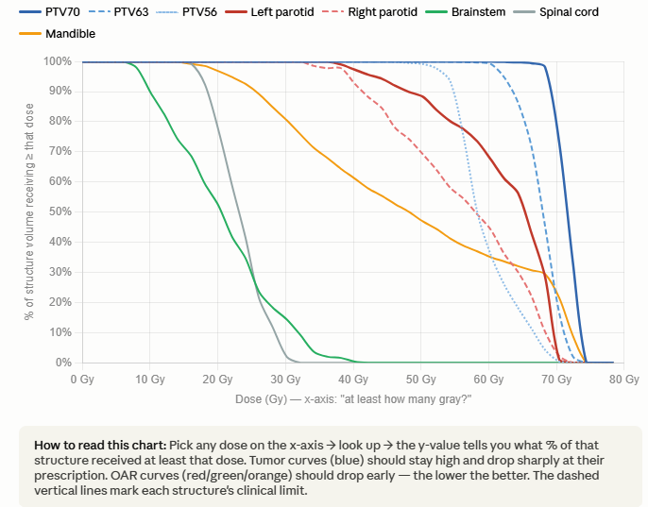
DVH — Dose Volume Histogram
The basic idea
After all 35 fractions, you have a 3D dose map. DVH compresses that entire 3D volume into a single 2D curve that answers:
"What fraction of this structure received AT LEAST X Gy?"

PTV- Planning Target Volume
Reading the DVH numbers
For PTV70 (the tumor — you WANT high dose):
- D95 = 73.8 Gy → 95% of the tumor got at least 73.8 Gy ✓ great coverage
- The goal is D95 ≥ 70 Gy — this plan achieves it

DIM - Dose Influence Matrix.
It answers: "if I fire beam X at intensity 1.0, how much dose lands at each voxel?"

The shape: (65,541 voxels × 9 beams)
Beam0 Beam1 Beam2 Beam3 Beam4 Beam5 Beam6 Beam7 Beam8
Voxel 0 [ 0.00 0.00 0.02 0.00 0.00 0.01 0.00 0.00 0.00 ]
Voxel 1 [ 0.05 0.00 0.00 0.03 0.00 0.00 0.02 0.00 0.00 ]
Voxel 2 [ 0.00 0.12 0.00 0.00 0.08 0.00 0.00 0.04 0.00 ]
...
Voxel 65541 [ ... ]
Each cell says: "beam J firing at intensity 1.0 deposits X Gy at voxel I"

Why 9?
The 9 beams come from 9 fixed gantry angles chosen for head & neck treatment:
0°, 40°, 80°, 120°, 160°, 200°, 240°, 280°, 320°

VOI = Volume of Interest
It's a named 3D region in the patient's body that matters for treatment planning. There are two kinds:
- TARGET VOIs — regions that must receive radiation (the tumors)
  - PTV_70, PTV_63, PTV_56 — Planning Target Volumes at different dose levels
- OAR (Organ At Risk) VOIs — regions that must be protected from radiation
  - Brainstem, spinal cord, parotids, mandible — Organs At Risk
- EXTERNAL VOI — the patient body outline (BODY), used by pyRadPlan to know where the patient is in space for ray tracing
IMRT = Intensity Modulated Radiation Therapy
Instead of one uniform beam hitting the patient, the beam is split into many small beamlets (bixels) each with its own intensity. This allows the radiation to:
- Conform tightly to the tumor shape
- Avoid nearby healthy organs (OARs)

